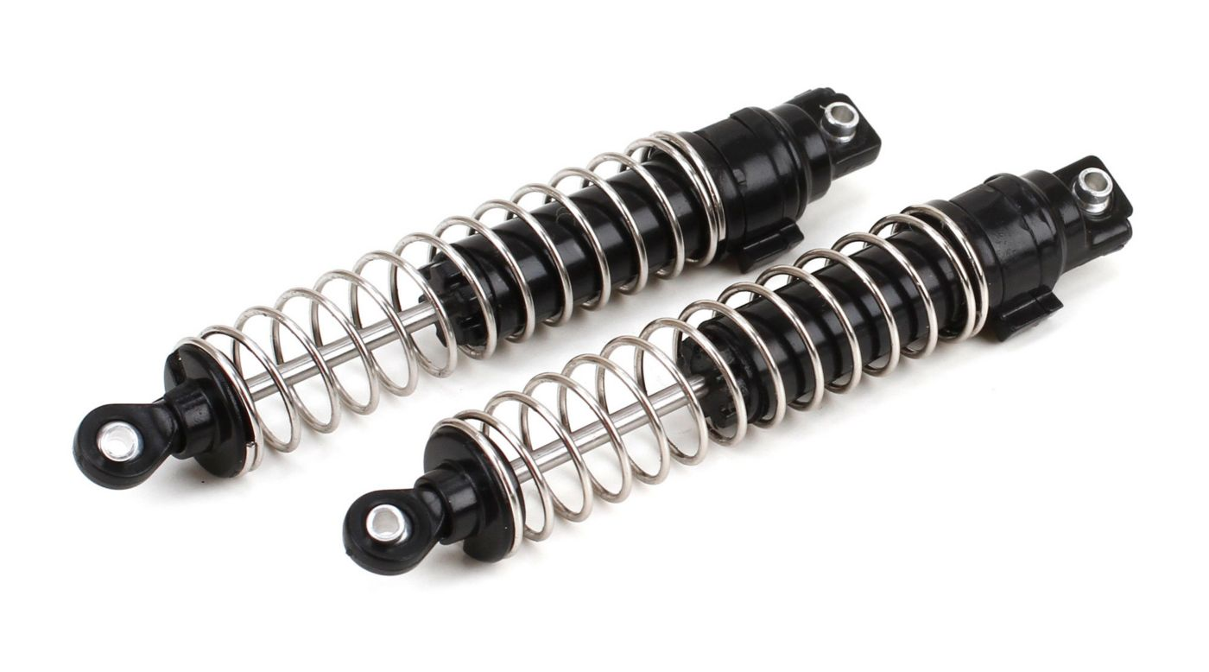

[Assembled Shock (2): SLK](http://www.horizonhobby.com/assembled-shock-%282%29%3A-slk-vtr213024)

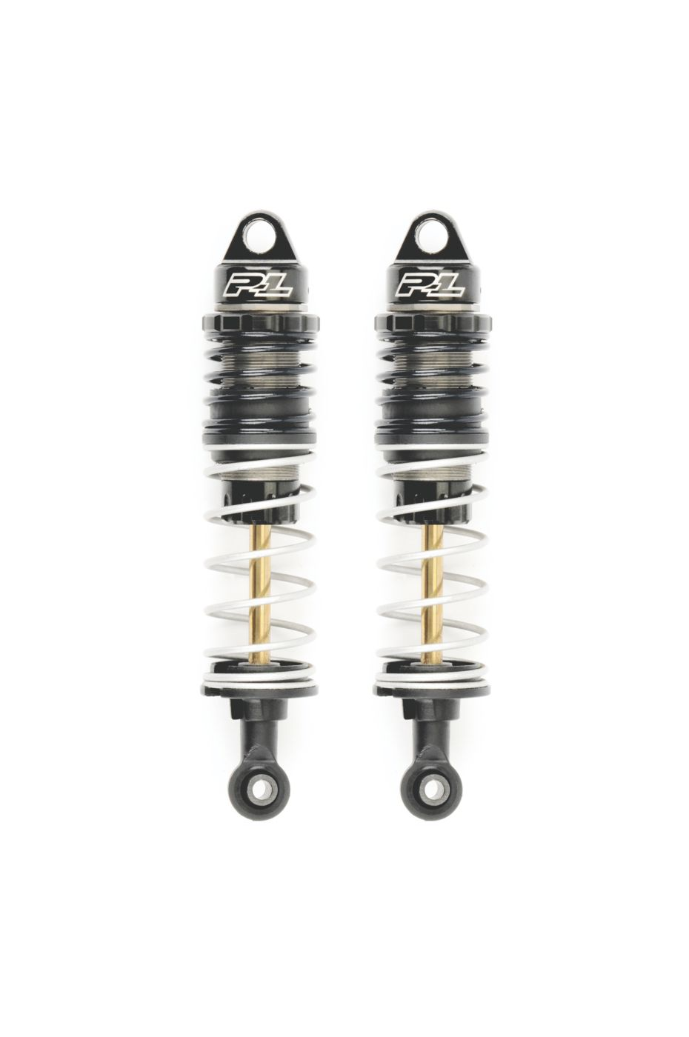

# [PowerStroke Shocks, Front: SLH](http://www.horizonhobby.com/powerstroke-shocks--front%3A-slh-pro606300)